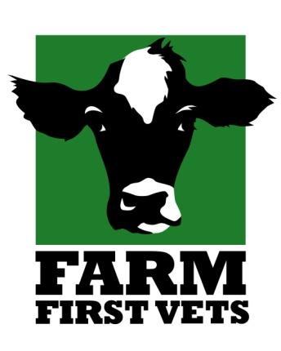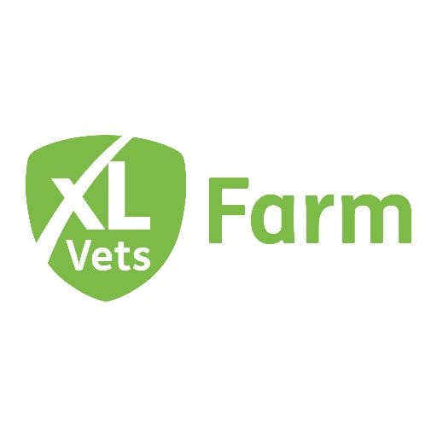

**Farm First Veterinary Services Student Application Form**

Name: Contact Number:

Address: Emergency contact Details :

Email:

Will you have a vehicle on placement? Year in University:

University/ College and Tutor/Staff point of contact:

Previous Farm Work Experience/ Farm EMS:

Requested Dates:

Date applied for placement:

Please provide a brief description indicating why you would like to see practice with us and your main aims for the future.

FOR INTERNAL USE 

Date booking confirmed Dates booked for placement

Placement booked by 





**Please return your form and photo by post or email to lauren.richards@farmfirstvets.co.uk**