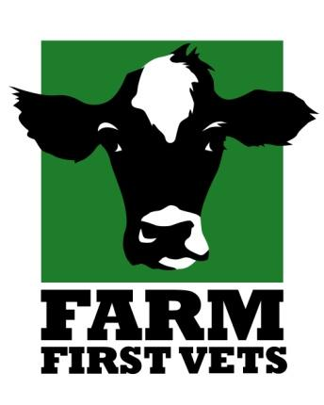

Farm First Veterinary Services Student Application Form

Name: Contact Number:

Address: Emergency Contact Details :

Email:

Will you have a vehicle on placement? Year in University:

University/ College and Tutor/Staff point of contact:

Previous Farm Work Experience/ Farm EMS:

Requested Dates:

Date applied for placement:

Please provide a brief description indicating why you would like to see practice with us and your main aims for the future:

FOR INTERNAL USE

Date booking confirmed Dates booked for placement
Placement booked by


Please return your form and photo by email to
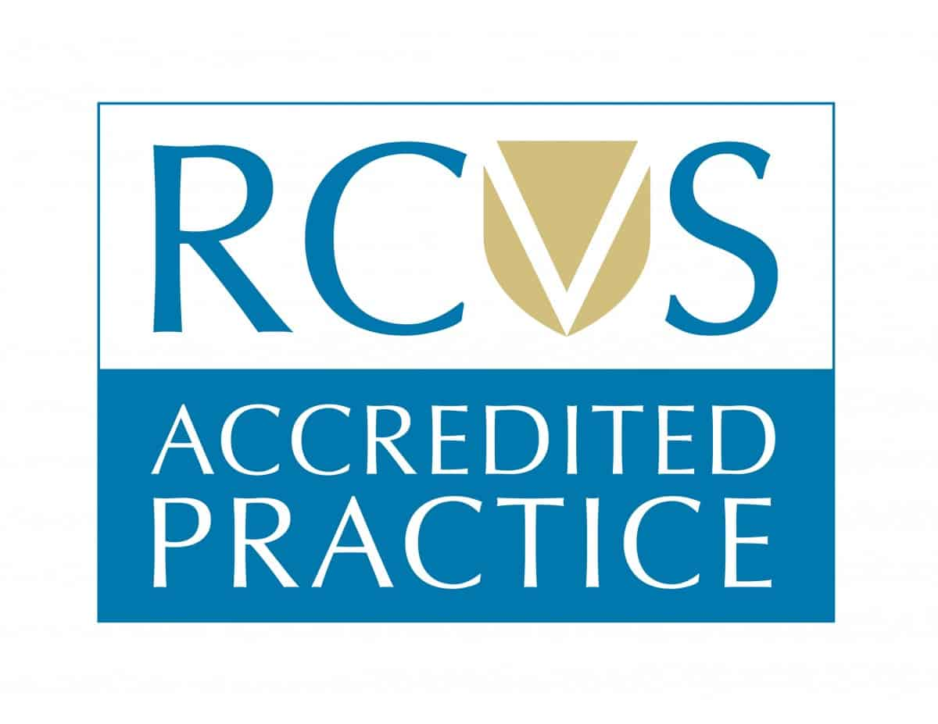
rachel.cook@farmfirstvets.co.uk or by post FAO Rachel Cook,
Farm First Veterinary Services, Unit 2, The Bryn Garage,
Penpergwm, Abergavenny, Monmouthshire NP7 9AT

